Practice Leaflet

Dr R Rashid BSc (Hons) MBBS (Hons) DCH DObst RCOG MRCGP
Tarbock Medical Centre
Manor Farm Primary Care Resource Centre
Manor Farm Road
Huyton
Liverpool
L36 0UB
Tel 0151 489 1444
Email GP.N83047@nhs.net

Practice Staff
Dr R Rashid-BSC (hons), MBBS (hons), DCH, DRLOG, MRCGP
Dr Nisha Benoy-Salaried GP -DRCOG, nMRCGP, Diploma in Diabetes with Diploma MSc.

Rachel Corness Practice Nurse
Melissa Malik Practice Nurse

Janet Mills Advanced Nurse Practitioner

Alicja Thompson Pharmacy Technician

Elaine Stockton Practice Manager
Chery Ashton Office Manager

Wendy Dooley Secretary
Joanne Richardson Receptionist/Administrator
Jenny Welsh - Receptionist/Administrator
Lyndsey Jones Receptionist/Administrator
Carol Stevenson Receptionist/Administrator
Sandra Jukka Receptionist/Administrator
Danielle Latham Receptionist Administrator
Fiona Gallagher-Baker Senior Administrator

Surgery Opening Hours
Monday 8.00am – 6.30pm
Tuesday 8.00am – 6.30pm
Wednesday 8.00am – 6.30pm
Thursday 8.00am – 6.30pm -Alternative Thursday’s 8.00am – 20.00pm
Friday 8.00am – 6.30pm

Surgery Consulting Hours
Monday 8.30am-15.00 13,30pm-18.30.pm
Tuesday 8.30am-14.00pm 14.00pm-18.30.pm
Wednesday 9.00am-14.30pm 15.40pm-17.30pm
Thursday 8.30am-14.30pm 15.00pm-18.00pm
(Extended Access, alternative Thursday’s 6.30pm -8.00pm)
Friday 8.30am-12.30pm 13.00pm-18.00pm

Extended Access
The practice offers evening appointments alternative Thursdays at the practice and weekend appointments at Whiston Health Centre. Contact the surgery to arrange an appointment.

Out of Hours
Please telephone the surgery on 0151-489-1444 and your call will be diverted to the duty Doctor. Out of hours services are provided by PC24 and this service is commissioned by NHS Cheshire and Merseyside Knowsley ICB. If it is not a medical emergency but you need medical help fast, please call NHS 111. Calls are free including mobiles.

Primary Care Walk in Centres
Are located in Huyton, Kirkby & Halewood. Your NHS Walk-in Centre offers treatment for minor illnesses and injuries without an appointment. It's a type of service that offers a convenient alternative to your GP. A team of experienced nurses offer treatment for: • Burns and scalds • Minor infections

Huyton Kirkby Halewood
Westmorland Road St Chad’s Drive Roseheath Drive
Tel 0151- 244-3150 Tel 0151-244-3180 Tel 0151-244-3532
Walk in centres are open 365 days a year and the opening hours for all the walk in centres are:

Monday – Saturday 8.00am-9.00pm
Sunday and Bank Holidays 10.00am-21.00pm

Blood Tests
Bloods can be taken at Nutgrove Villa, Prescot Primary Care Resource, Manor Farm Resource Centre, Halewood Centre and St Chad’s Centre. A booked appointment is necessary. Tel 0151-351-8530, housebound patients telephone 0151-3578533 or online www.merseycare.nhs.uk/our-services/knowsley/phlebotomy-blood-test

New Patients
Patients can register with the practice if they live in our practice boundary. The practice boundary covers Huyton Town Centre, Tarbock Green and Roby. Please see the inner area of the black marking shown on map is our boundary. On joining the practice all new patients have the right to express their preferred GP and offered a health check with the Practice Nurse. This service is also offered to patients between 16 – 75 yrs., who have not seen a Doctor in the last 3 yrs. Over 75yrs are offered an annual check-up.

Named Accountable GP
All patients are allocated Dr Rashid as their named accountable GP. Dr Rashid will be responsible for the management of all the appropriate services we provide and will ensure they are delivered to each of our patients where required, on the patients behalf. However this does not mean that he will be the only GP who will provide care to our patients, other clinicians will also provide services, Patients can and should feel free to choose to see any clinician of their choice.
Patients over 75yrs their named accountable GP will work with relevant health and social care professionals to deliver a multi- disciplinary care package that meets the need of the patient and ensuring that these patients have access to a health check.

Home Visits
If a home visit is needed, please telephone the surgery before 10am where possible. You may be contacted by one of the Doctors for further information. Every effort should be made to attend the surgery.

Repeat Prescriptions
To order your repeat prescription tick item(s) on your repeat request and pop it into the box situated in the waiting room. We will also accept prescription by telephone if you are housebound or over 70years of age between the hours 9.00am-13.00pm. Please allow 48 hours’ notice. Alternatively you can post your request or use the internet service, please ask at reception. A delivery service maybe provided for housebound patients, for availability of this service please contact your local chemist.

Training Practice
The practice may have medical students on placement. We may ask your permission for them to sit in your consultation with the Doctor or Nurse. They will always be under supervision and will make no decisions regarding your treatment.

Services
The services provided by the surgery include Antenatal and Postnatal care, Baby Checks and Immunisations, Asthma, Diabetes, Hypertension, Cervical Cytology, Travel Vaccinations and Well Person Clinics.

Practice Nurse
The Practice Nurse only sees patients by appointment. Should you need to speak to the Nurse please contact reception.

Health Visitor
The Health Visitor can be contacted via Manor Farm Resource Centre.

Midwife
The midwife is in attendance 1 day per week during antenatal clinics for general advice and assistance.

Consent and Confidentiality
The doctors and staff and others, who are caring for you, keep records about your health and any care or treatment you receive from the NHS. It is important to keep records to help ensure that you receive the best possible care from us. Your records are kept in a safe place in the surgery either on computer or paper files. Receptionists and secretarial staff are responsible for keeping your records in order and will, from time to time access your records. We may need to share some information about you so that we can work together for your benefit. We will pass on information about you if they have a genuine need for it. There may also be other agencies that may ask for information but we cannot give
details to anyone else without your consent.

Rights and Responsibilities
If you have a preference to see a particular clinician, please make your request known to reception. .
If you cannot keep an appointment you must inform the surgery.
We will not tolerate any violent or abusive behaviour. Please be aware that you may be removed from the practice list.

Details of Primary Medical Services available in this area may be obtained from:
Cheshire & Merseyside Integrated Care Board (ICB), Knowsley Place
Details of primary medical services in the area may be obtained from the ICB:
Knowsley Place Nutgrove Villa, Westmorland Road Huyton Merseyside L36 6GA 0151 244 4126
knowsley.communications@cheshireandmerseyside.nhs.uk

Useful Numbers
NHS Direct ……………………….. 111
Huyton Walk in Centre ………….. 0151 244 3150
St Helens Walk in Centre ……….. 01744 627400
Whiston Hospital…………………. 0151 426 1600
St Helens Hospital ……………… . 01744 26633
Royal Liverpool Hospital ………. 0151 706 2000
Alder Hey ………………………… 0151 228 4811
Knowsley Access Team………….. 0151 443 2600
Police ……………………………... 0151 709 6010
Davey’s Pharmacy ……………….. 0151 489 4004
Lloyds Pharmacy ………………... 0151 489 5817
Boots the Chemist ………………... 0151 489 1465
Superdrug ………………………… 0151 489 6860

Access for Disabled Persons
There is access to disable parking and suitable access to and in the building.

Carers
Please inform the practice if you are looking after someone or if someone looks after you. There are a wide range of services available to you, if you would like to discuss them please ask at reception. The information is also displayed on the notice board in the waiting room. The carer link at our practice is Cheryl Ashton.

Information Sharing
Please note that how your information is shared is provided in a leaflet in the waiting room, but if you would like to discuss this please ask at reception.

Safeguarding
Doctors and staff will do there utter most to protect children and vulnerable patients by following our local policies and guidelines.

Accessible Information
If you have any communication or information needs the practice needs to be aware, please inform ther staff so that we can help put a system into place in order to help meet your needs.

Patient Reference Group (PRG)
The practice is keen to ensure our patients have a say and get involved in the services that we provide. If you would like to join our group and attend our meetings please ask at reception.

Comments and complaints
The receptionist is pleased to help you with any queries you may have, arrange appointments, order repeat prescriptions etc. There is a box on the reception desk for comments, suggestions or complaints, however we do operate a complaints procedure which you can address to the Practice Manager either by telephone, post or email GP.N83047@nhs.net if you prefer not to contact the practice directly you can contact Patient Advice and Liaison Service (PALS) on 0800-218-2333
The practice falls within the, Cheshire & Merseyside Integrated Care Board (ICB), Knowsley Place
based at Nutgrove Villa, Westmorland Road, Huyton, L36 6GA

Welcome to Tarbock Medical Centre

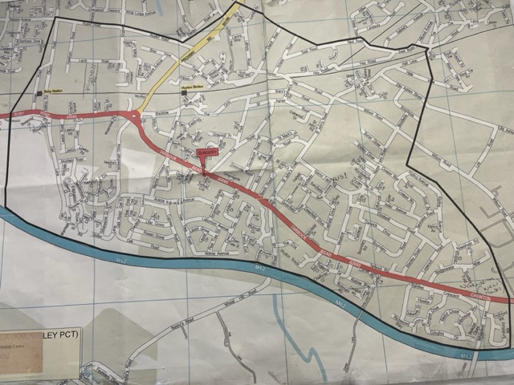

Practice boundary shown inside the black marking

